|  |
| --- |
| a report on semester projects  CIT 380 |
| Gunther Schurr |



# Introduction

I was involved in 3 projects outside of work and other classes. I was able to complete most of these projects, and gain some good experience in the process. I will attempt to articulate the outcomes in this report.

### **Interdependent**

### **Disciple-Leader Conference**

This conference is designed to bring participants closer to the Savior. It is a one-day conference where participants attend workshops, hear speakers, and accomplish a service project. I was on the council responsible for planning the Fall 2019 conference, which was held on October 18th.

#### Organization

I was on a council with 9 other people (10 total), which made 5 partnerships, each with their own role. We had our director and assistant director, Logistics, Recruitment, Service, and Social Media. I was partnered with Kaylani, who I have worked with before, and we were over Logistics. Logistics is responsible for scheduling every event of the conference, pricing all food, and training and scheduling all volunteers. (We commonly use the term “volunteer” to refer to non-council DLC members, but in reality, we are all volunteers.) As a council, we met together basically every day; however, we also had a more formal meeting once a week where we reported what we had done, and others would offer their input or questions as needed.

#### Budget/Resources

Disciple-Leader Conference is run through Student Support; Student Support is responsible for campus events, such as the Christmas tree lighting, Get Connected (new student orientation), FHE service projects, skills mentoring, and other events. Disciple-Leader Conference received about $3500 for this semester, which is fairly tame compared to other cited events. Kaylani and I were responsible for managing most of this budget, and we worked with our director on the proper distribution of available funds.

#### time

Essentially, all days leading up to the week of the conference are planning and setup days. We spent an average of 2 hours a day on DLC. **Based on my calculations, I spent about 73 hours preparing, executing, and cleaning up from the conference.** I do not have a meticulous time-tracking sheet to document this, but if a sort of “proof” is needed, each council member can vouch for my involvement.

#### Personnel

As a council, we oversaw (“worked with” also fits) about 41 volunteers. Kaylani and I have been trying to streamline the training for the volunteers, and this time we got the whole council involved in the training process—a marked improvement from previous semesters. We tried to get to know the names of each volunteer, which mostly worked. As touched on previously, Kaylani and I prepared schedules for each volunteer based on their group, and gave them a lanyard with this schedule on it so they would have it with them at all times. Each volunteer was also put into a group chat where updates could be sent out.

#### Outcome - Broad

As a whole, the conference went well. I believe our final count for attendees was just over 400 people. The volunteers worked efficiently on the back-end, and the participants’ feedback was very favorable. We had a survey we encouraged people to take, and based on that data, it appears that almost every person was glad that they went.

#### Outcome - Personal

This is not the first time I’ve been on the council, but each time is a growing experience. Managing my time properly during those hours of planning is getting better; I enjoy the company of others, and this company is not bad, but at the end of the day, work and planning still has to be done, and I felt that I was more efficient at that this semester. I feel that my interactions with volunteers has also improved, and that I’m clearer in explaining my expectations.

In the future, I will try to present a few project management principles to the director to see if we can improve our productivity even more. I’ve tried to eliminate the “silo effect” as much as possible this semester, which I why I pushed so much for Google Drive, and it’s vastly improved our documentation and collaboration.

While I do seek for a more streamlined process, I hope to not get stagnant. There is one area I know I can improve on, and that is in recruitment and advertising. I’ve gotten so “good” at planning the conference itself that actually getting people to it is most times an afterthought. I know we have dedicated council members for this, but I’m probably just using that as an excuse. If I want good volunteers, I should get them, instead of waiting for them to be handed to me. If I want more people to come, I should actually tell people about the conference. This may sound like a very independent line of thinking, but I recognize my shortcomings.

### **Independent**

### **Code In The Dark (CITD)**

Code In The Dark is an activity I planned and executed for the CIT Society. Code In The Dark’s history is hard to track. There is no Wikipedia page, no About page—just a slew of organized events, mostly held in Europe. The CIT society picked it up after seeing a booth across from us showing what CITD was. The only real “official” website is codeinthedark.com, and provided the framework for the editor participants used in the competitions.

The name of the game is simple: recreate a webpage from an image without being able to see the live results of the code. This means that you’re “flying blind” and don’t see the final render of your code until the voting procedure at the end.

#### Organization

I was personally responsible for the planning and execution of the events, including providing music and basic instruction (no alcohol at these events).

Isaac, our CIT society president, normally scheduling CITD to occur every other week; during the week before, I would select a website that was fairly simple that participants would try to recreate using HTML and in-line CSS. The editor at codeinthedark.com/editor is open-source, and the code is found on their GitHub repository. I cloned their repository onto my own, and replaced the reference image and instructions with my own. I also had to update all the dependencies (like pictures or logos) that participants might need in the background files too. Each round lasted about 20 minutes, which felt like quite a time crunch for participants to get everything typed up.

To see what our last competition reference was, the editor I have edited is available at gunther-s.github.io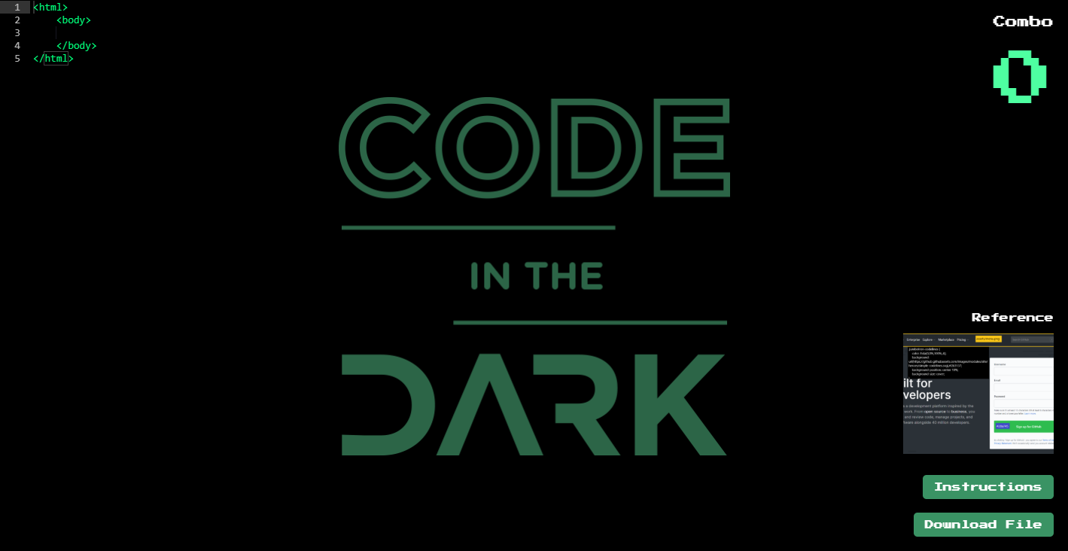

#### Budget/Resources

This was mostly handled by Isaac, but 3 of the 5 CITD events had pizza at them. Aside from that, the participants did not pay to enter, and as mentioned earlier, the code to the editor is open source.

#### time

**Based on my calculations, I believe I spent 17 hours (rounded) preparing and executing CITD events.**

#### Outcome - Broad

As far as participation goes, it could have been better—not just for CITD, but for the society as a whole. Our largest group was our first, which was about 9 participants. This dwindled as the semester continued, so that by the end (round 5) we had 2 participants. This also reflects the society attendance as a whole.

However, I would say that, for those that participated, the experience itself was very unique, and I think it helped open the eyes of those involved as to just how much they know about HTML and CSS. Some who came in with an air of superiority or proficiency soon realized that this task was different than they assumed. The best-looking final results often went to those who knew the basic of HTML and CSS, as opposed to those that knew more advanced tactics, but just used auto-complete to build the basic frame.

#### Outcome - Personal

Naturally, this experience improved my HTML skills as I dug into making each website work with the unique CITD stipulations. I can’t say that I’m proficient, but I’ve improved. This experience also helped me better plan and serve a desired deliverable: if I didn’t make content for the event, it wouldn’t happen, and this is especially bad when it’s already a planned event.

I also realized more what helps me, and what hinders me, when trying to concentrate on a more complex problem. I don’t especially like loud distractions, and if I’m in that environment, I work at a slower pace—it’s not impossible, it’s just not as efficient.

Like DLC, I could have done better in advertising the event, as well as the CIT society as a whole. Trying to build up the society will take effort, and I need to “put my back into it” to ensure that the events I’m planning actually have people participating in them.

### **Dependent**

### **CIT 380**

I decided to take CIT 380 because I received some advice saying that my busiest semester would be the best time to take it. Since the class was “pretty easy” I was assured I wouldn’t have to worry so much about it. I probably should have realized earlier how incorrect this was.

#### Organization

During class periods, I didn’t align myself with any sort of group, because I already mostly knew what I needed to do project-wise. I was not trying to avoid people, but at the time, I didn’t really see a need for them. In fact, going to class was sometimes very distracting, as there were…some certain class members, who didn’t care at all, and were quite disruptive. Looking back, I probably should have just joined a group and completed a relatively straightforward project with another group that finished a month before the semester ended, or something like that.

#### time

Perhaps I do get the endurance award. I attended class every available day except for 2 periods I think when I was sick. I will admit up front that a fair amount of class time was not beneficial. Essentially I waited for those moments when the instructor would speak or explain a principle, and most other times I did work for projects. The politics during the first third of the semester on who actually was going to “lead” the class were more distracting than helpful, and I wondered if I should even attend class after that. But I stayed, clapped for the presentations that some gave, and voiced my opinion as needed.

#### Outcome - Broad

Based on my grade in Canvas, I have failed this class. I believe I only completed 3 assignments from those posted. I think my initial realization during the beginning of the semester that they were not “required” killed my motivation to do them. Things like discussion boards seemed very unappealing compared to actually completing the projects. I did study from a selection of the resources included in the course, mostly towards the end of the semester, trying to bolster my knowledge of project management principles and vocabulary. I don’t think I did especially well in this, because I believed I would learn more by experiencing project management as opposed to just reading about it. However, going to class and hearing phrases or concepts here and there made me self-conscious at my ignorance of the “lingo.”

#### Outcome - Personal

This class is unique. I would say that I’ve grown a lot as a project manager this semester, but I could have been better. Like other students have done in the past, I think I let the completion of projects get in the way of understanding the material. I know that actual experience as a project manager is very valuable, but in my opinion, the balance between projects and theory could have been better.

I actually feel this urge to tell future students about the class, and how to actually navigate it. Maybe that’s a good thing? I would tell a prospective student to take the class in a flex-semester, to really dig into the knowledge, and in all honesty, not show up to the first day of class knowing what you want to do in a project. Join a group that has no idea what they’re doing and sling some ideas around until something sticks. Understand the vocabulary, make weekly or bi-weekly reports, meet with the instructor 5 or more times, and bug everyone in the class with new ideas and project updates. Then, I believe, the students would understand.

*“I returned, and saw under the sun, that the race is not to the swift, not the battle to the strong, neither yet bread to the wise, nor yet riches to men of understanding, nor yet favour to men of skill; but time and chance happeneth to them all.”*

*Ecclesiastes 9:11*